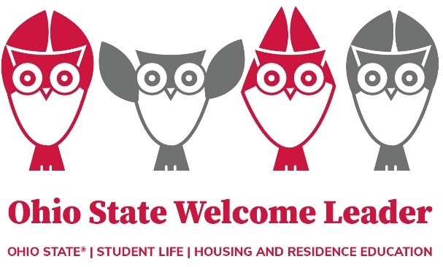**Ohio State Welcome Leader (OWL) Program**

**Frequently Asked Questions**

**When do OWL student leaders move to campus?**

* **Ohio State Welcome Leaders (OWLs)** = Wednesday, August 20th *(OWL Training is at 7pm in Hitchcock 131)*
* **OWL-Coordinators (OWL-Cs)** = Sunday, August 17th*(OWL-C training begins Mon. 8/18 at 9am)*
* **OWL Area Coordinators (ACs) =** Saturday, August 16th*(AC training begins Sat. 8/16 at 5pm)*

**What does my Move-In Timeslot mean?**

* Your Move-In timeslot is the time you have chosen to arrive at your residence hall to start your move. If needed, changes can be made to your chosen timeslot through the housing portal.
* [**Sign-up for a Move-In timeslot**](https://go.osu.edu/moveinsignup)
  + While we encourage you to try to find a time around 2pm or before to move to campus, any timeslot 4:30pm or before is fine. If your building does not have a timeslot available before 5pm, please email [wheeler.1110@osu.edu](mailto:wheeler.1110@osu.edu).

**Where Can I find the OWL Program Schedule(s)?**

* Once finalized, the schedules will be posted on the [OWL website](https://involvedliving.osu.edu/owl-program).
  + **Wednesday 8/20 =** OWL Mandatory Training begins at 7pm @ Hitchcock Hall 131
  + **Thursday 8/21 =** OWL Hoot Fest is from 6-8pm @ Ohio Union – Archie Griffin Ballroom
    - A night of fun activities, giveaways and food/drinks while they last to thank you for being an OWL this year!

**What do my Move-In Shifts mean?**

* Your Move-In shifts are the volunteer shifts you’re required to sign-up for as an OWL and OWL-Coordinator. OWLs are required to sign-up for two Move-In shifts and OWL-Cs do a little more and should refer to their emails. [**Sign-up for your required Move-In shifts**](https://maestroweb.studentaffairs.ohio-state.edu/trk/click?ref=z10j1mkdhf_0-3b7d_0x310f45x0658)

**Questions?**

* If your question is housing related – please email [housing@osu.edu](mailto:housing@osu.edu) or call 614-292-8266
* If your question is OWL program related – please email Leah [Wheeler.1110@osu.edu](mailto:Wheeler.1110@osu.edu)